

**MEMORANDUM OF UNDERSTANDING**

This is a document validating an agreement between **MR. OGABOR JOHN AND MRS. DANIEL WALES** for the collaborative of 20% interest over a sum of **TWELVE MILLION NAIRA ONLY (N12,000,000) paid on the 14th of May, 2020.**

There is a binding agreement to pay the initial capital invested, alongside the interest, **FOURTEEN MILLION, FOUR HUNDRED THOUSAND NAIRA ONLY (N14,400,000) on the 14th of June, 2020** by **MR. OGABOR JOHN TO MRS. DANIEL WALES.**

Attached with this document is an evidence of payment by **MRS. DANIEL WALES.**

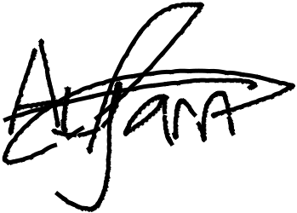

_________________________

_~~__~~_____~~___~~_~~_~~___________



**MRS. DANIEL WALES**

**MR. OGABOR JOHN**

***(CEO, JOHN INVESTMENTS)***